**Paradox of Choices- Swiggy**

**About Swiggy**

**Vision:** To elevate the quality of life of urban consumers by providing unparalleled convenience

**Mission:** To change the way India needs

**Problem Definition**

Swiggy users are increasingly overwhelmed by the vast number of food options available on the platform, leading to decision fatigue, delayed ordering, and in many cases, order abandonment. This issue is especially prominent among younger users (Gen Z and millennials), who frequently browse but hesitate to order due to the mental load of evaluating too many choices.

If addressed, Swiggy can improve conversion rates, reduce cart abandonment, and enhance user satisfaction — directly impacting revenue and customer retention. Solving this will empower users to make quicker, more confident decisions, transforming indecision into action and reinforcing Swiggy as a time-saving, user-centric platform.

**Validation of the problem**

**Research Insights on Paradox of Choices:**

* + If users have too many choices, they are 10 times less likely to buy/perform an action
  + Hunger significantly alters people decision-making, making them impatient and making them settle for small reward that arrives sooner rather than a larger one promised later
  + Very few choices are not good either, because users feel like they are compromising because they are unable to find options that best fit their needs
  + Ideal number of options for a person is somewhere between 8 and 15 for optimal decision making

**User Research and Interview Insights:**

* + When given enough time, users like having the option to explore. But in urgent situations, like ‘ordering in office before a meeting’, or ‘reaching home late and tired’, users want a quick simple food suggestion
  + Even in urgent situations, users get bored of re-ordering from Favourite places repeatedly. They would like the option to order new safe dishes quickly
  + As the time for browsing increases more than 10 minutes, it is more likely that they will abandon the cart.
  + If a user is completing an order within 10 minutes, it is usually because they have opened the app with something in mind or with the intention to order someone else’s recommendation. It is very rare that they have discovered something new on the app

**Value Generate by solving this problem:**

* + For users: Solving this issue makes it easier and faster for users to decide what to eat. It saves them time, reduces frustration, and helps them feel more satisfied and confident with their order.
  + For Restaurant owners: Increasing the predictability factor of specific dishes being ordered, helps restaurants prepare for larger upcoming orders of those dishes
  + For Swiggy Platform: Solving for this issue will increase total orders/month, which is swiggy’s north star metric, which will lead to increased user retention

**Understanding the target audience**

Swiggy's core customers range from urban customers who use the platform for instant, convenient access to food and essentials.

For our problem, the key target is young, tech-savvy customers in the age group of 18–30, mainly college students and young working professionals in metro and tier-1 cities. These customers are mobile-first, tech-savvy, and use food delivery apps as a daily utility and not as an occasional indulgence.

**User Personas:**

| Name | Age | Persona Type | Behaviour | Pain Points / Needs |
| --- | --- | --- | --- | --- |
| Ananya | 21 | College Student | - Orders during late nights and exam weeks  - Budget-conscious  - Often indecisive | - Spends too much time browsing  - Usually ends up reordering  - Needs help narrowing choices |
| Rohan | 26 | Young Professional | - Orders lunch/dinner while working from home  - Time-constrained | - Gets overwhelmed by options  - May exit the app if he can’t decide quickly |
| Priya | 28 | Fitness Enthusiast | - Looks for healthy/veg options  - Actively uses filters | - Filters still return too many results  - Needs quick, relevant recommendations |

**Solution**

**Goals**

* To shorten average time to order
* Reduce Decision Fatigue
* Increasing conversion rate (from app open to order placed)
* Improve user satisfaction and retention

Non-Goals*– (out of scope)*

* Not Changing entire UI/UX of Swiggy
* Not reducing actual number of restaurants or menu items
* Not changing discounts, pricing or restaurant partnerships
* Not targeting first time users

***Solution 1:***

*Order Circle: Zomato uses users' contacts to show what friends are ordering, helping users make quicker, more confident choices. It builds trust by highlighting popular dishes and restaurants among their close circle, reducing the effort needed to decide.*

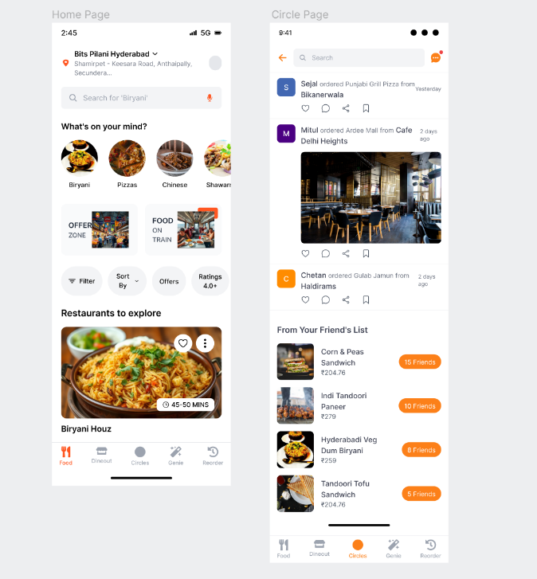

***Solution 2:***

*Tribe:* *A smart AI system groups users with similar food preferences into “tribes” based on their order habits (like cuisine, budget, or time). It then suggests restaurants popular within your tribe to make choosing easier and more personalized.*

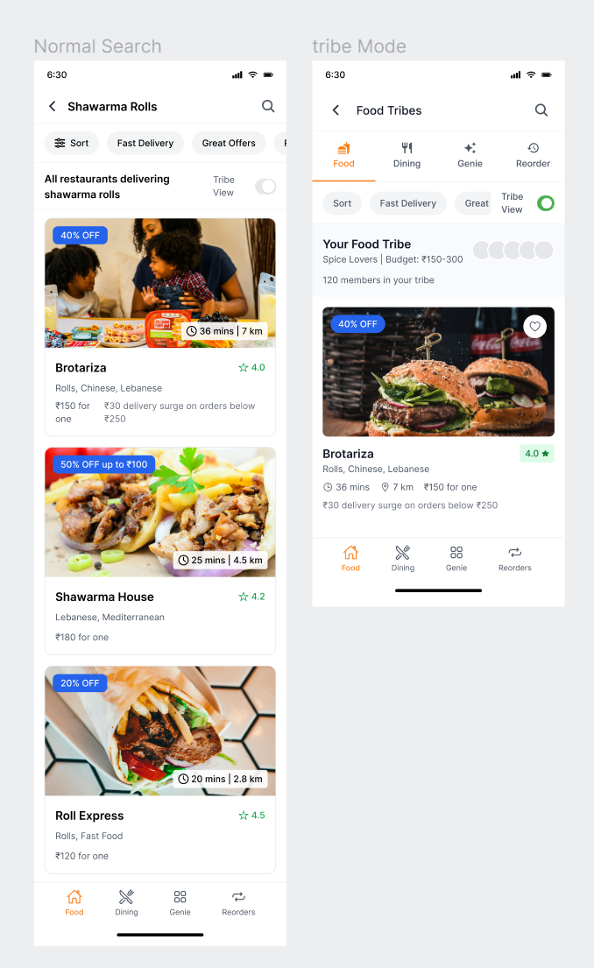

***Solution 3:***

*Mini Food Reels:* *Short, engaging 10–15 second vertical videos created by restaurants or popular food bloggers, showcasing popular or signature dishes. These reels are featured directly in the Swiggy app within the dish listing or restaurant page.*

***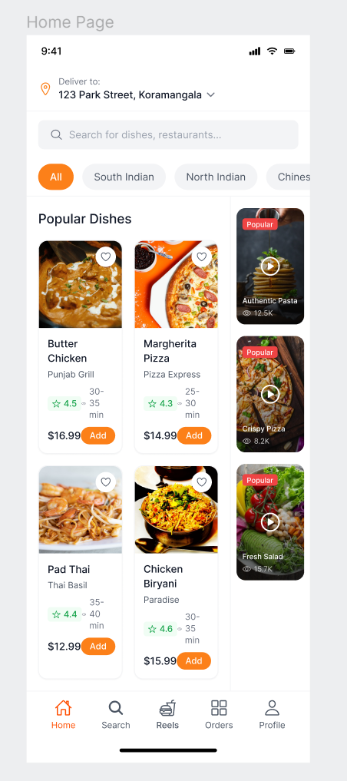****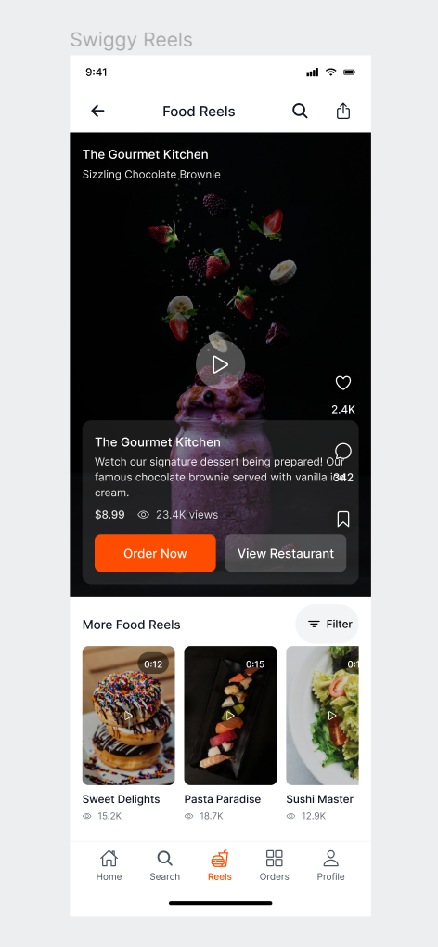*

**Prioritisation: (RICE framework)**

| **Solution** | **Reach** | **Impact** | **Confidence** | **Effort** | **(R×I×C)/E Score** | **Extra / Comments** |
| --- | --- | --- | --- | --- | --- | --- |
| **Order Circle** | **75%**  CTA driven, would require people to actively take part in review and rating when they order | **2 [Medium Impact]** Efficiency of this feature will depend on the users circle | **75%** It may give results that are not unique or creative | **2 [Medium]** With vast data available - creating a feed by collating the data in one place | **56.25** | Easy to understand and builds social habit |
| **Tribe** | **80%** CTA-driven, visible near recommendations | **3 [High Impact]** Efficient filters to make the process or ordering easier and faster | **85%** Mass preferences align | **3 [High]** Integrate AI into the and ensuring the AI gives proper recommendations | **68** | Works best when users have a high order history |
| **Mini Food Reels** | **90%** Integrated into listings & menu | **2 [Medium Impact]** Strong visual decision trigger, won’t necessarily reduce the time taken to order | **80%** Reels of popular food items might make people more indecisive about what to order | **3 [High]** Requires video infra & moderation | **48** | Most engaging, |

**Success Metrics**

| Type of Metric | Goal | Metric |
| --- | --- | --- |
| North Star | Increase total number of orders per user | - No. of orders increased per user - Avg. no. of users ordering from tribe-suggested restaurant |
| Secondary (Awareness) | Track exposure to the tribe feature | - No. of people visiting the tribe tab - No. of people clicking the tribe toggle |
| Secondary (Adoption) | Measure usage of tribe recommendations | - % of users ordering in a day who ordered from tribe recommendation |
| Secondary (Accuracy) | Evaluate relevance and effectiveness of early suggestions | - Avg. no. of people ordering from the first 2 cards of tribe category selection |
| Secondary (Conversion) | Understand impact of visits on actual orders | - % of users visiting the tribe page who placed an order from tribe suggestions |
|  |  | - % of users placing a second order after clicking the nudge on the delivery page |
| Secondary (Retention) | Measure long-term engagement with tribe | - No. of users ordering their second order from a tribe suggestion |
|  |  | - % of users returning to the tribe page after their first interaction |

**Risks & Mitigations**

**1. Cold Start: Limited data for new users**  
New users may not have any order history, making it hard to build a taste profile.

**Solution:** Prompt users with a quick, optional questionnaire during onboarding to establish a baseline taste profile (e.g. spice level, cuisine preferences).

**2. Lack of transparency in taste-based recommendations**  
Users may not trust the algorithm if they can't see how they're being profiled.

**Solution:** Display the user’s taste profile in a dedicated section and allow them to edit or fine-tune their preferences at any time.

**3. Subjective perception of taste**

The same dish may be perceived differently by different users (e.g., spice tolerance).

**Solution:** Collect granular feedback post-order by asking users to rate specific taste and texture attributes (e.g., "Too spicy?", "Too oily?"). Use this to refine future recommendations.

**References**

<https://www.financialexpress.com/business/industry-swiggy-cofounder-sriharsha-majety-our-mission-is-to-change-the-way-india-eats-933235/>

<https://faculty.washington.edu/jdb/345/345%20Articles/Iyengar%20&%20Lepper%20(2000).pdf>

<https://www.sciencedaily.com/releases/2019/09/190916103811.htm#:~:text=The%20study,%20carried%20out%20by,promised%20at%20a%20later%20date>.

<https://www.caltech.edu/about/news/scientists-uncover-why-you-cant-decide-what-order-lunch-83881>

<https://www.dundee.ac.uk/stories/dont-make-major-decisions-empty-stomach-research-suggests>

<https://www.internationaljournalssrg.org/IJEMS/2024/Volume11-Issue6/IJEMS-V11I6P101.pdf>

<https://skillcircle.in/swiggy-business-model-marketing-strategy/>